HTML AND CSS EXAM –ALL THE BEST

User Registration and Authentication

Description:

Design and develop static web pages for user registration and authentication using only HTML and CSS.

Question:

Create a registration form and a login form using HTML. Include fields for username, email address, and password in the registration form, and fields for username/email and password in the login form. Implement client-side validation for the registration form to ensure all fields are filled out and the email address is in a valid format. Style both forms using CSS to create a visually appealing user interface.

**Registration.html:**

<!DOCTYPE html>

<html lang="en">

<head>

    <meta charset="UTF-8">

    <meta name="viewport" content="width=device-width, initial-scale=1.0">

    <title>Registration Form</title>

    <link rel="stylesheet" href="Registration.css">

</head>

<body>

    <h1>Registration Form</h1>

    <form class="registration">

        <label for="username">Username:</label>

        <input type="text" name="name" id="name" placeholder="enter username" required><br><br>

        <label for="email">Email:</label>

        <input type="email" name="email" placeholder="enter email" id="email"><br><br>

        <label for="password">Password:</label>

        <input type="password" name="password" placeholder="new password" id="password"><br><br>

        <label for="password">Confirm-Password:</label>

        <input type="password" name="password" placeholder="retype password" id="password"><br><br><br>

        <input type="submit" value="Register" id="button">

        <input type="submit" value="Cancel" id="button">

    </form>

    <a href="Login.html" target="_blank">Login</a>

</body>

</html>

**Login.html:**

<!DOCTYPE html>

<html lang="en">

<head>

    <meta charset="UTF-8">

    <meta name="viewport" content="width=device-width, initial-scale=1.0">

    <link rel="stylesheet" href="Registration.css">

    <title>Login</title>

</head>

<body>

    <h1>Login Form</h1>

    <form class="login">

        <label for="username">Username:</label>

        <input type="text" name="name" placeholder="enter username" id="name" required><br><br>

        <label for="password">Password:</label>

        <input type="password" name="password" placeholder="enter password" id="password" required><br><br><br>

        <input type="submit" value="Login" id="button">

        <input type="submit" value="Cancel" id="button">

    </form>

</body>

</html>

**Registration.css:**

*{

    margin: 0;

    padding: 0;

}

body{

    background-color: beige;

    margin-bottom: 100px;

    font-size: 20px;

}

h1{

    text-align: center;

    margin: 50px;

}

p{

    text-align: center;

    color: blueviolet;

}

.registration{

    border: 2px solid;

    border-radius: 20px;

    background-color:cyan;

    width: 350px;

    height: auto;

    padding: 50px;

    margin-left: 370px;

    padding-left: 130px;

    margin-bottom: 50px;

}

a{

    padding-left: 600px;

}

.login{

    border: 2px solid;

    border-radius: 20px;

    background-color: darksalmon;

    width: 350px;

    height: auto;

    padding: 50px;

    margin-left: 350px;

    padding-left: 130px;

}

#button{

    margin-left: 45px;

    padding:6px 10px;

    border-radius: 8px;

}

#button:hover{

    background-color:deeppink;

    cursor: pointer;

}

Output:

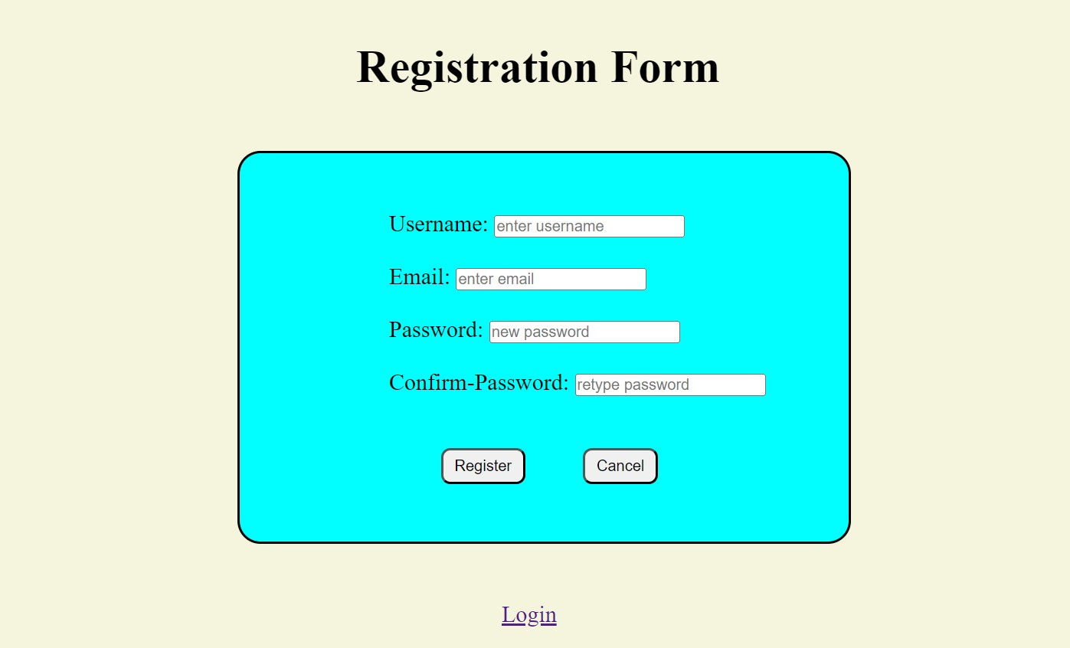

After Clicking Login:

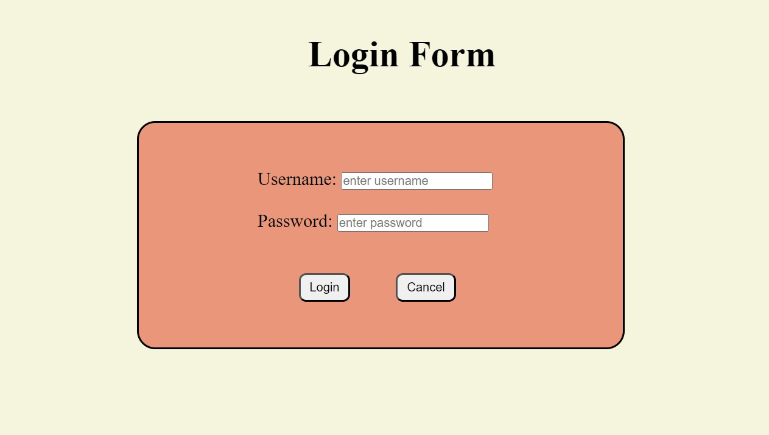

Use Case 11: Product Showcase Website

Description:

Develop a static website showcasing a collection of products. Each product should have a title, description, image, and price displayed on the website. Implement a responsive layout using HTML and CSS to ensure the website looks good on various devices. Include navigation links or buttons to allow users to browse through different product categories.

**Produsct.html:**

<!DOCTYPE html>

<html lang="en">

<head>

    <meta charset="UTF-8">

    <meta name="viewport" content="width=device-width, initial-scale=1.0">

    <title>Product Showcase</title>

    <link rel="stylesheet" href="Product.css">

</head>

<body>

    <header>

        <h1>Polimera's</h1>

        <p>For fresh fruits and vegetables</p>

    </header>

        <nav>

            <a href="#home">Home</a>

            <a href="#fruits">Fruits</a>

            <a href="#vegetables">Vegetables</a>

            <a href="#contact">Contact</a>

        </nav>

        <div class="container">

        <!--Fruits section-->

        <h2 class="heading">Fruits</h2>

        <div class="fruits" id="fruits">

                <div class="product">

                    <img src="Images/Mango.jpg" alt="Product 1">

                    <h2>Mango</h2>

                    <p>Mango is a juicy, nutrition-rich stone fruit with exclusive fragrance, flavour, varieties and health enhancing benefits.</p>

                    <p>₹139/Kg</p>

                    <button onclick="addToCart('Product 1', 10.99)">Add to Cart</button>

                </div>

                <div class="product">

                    <img src="Images/Apple.jpg" alt="Product 2">

                    <h2>Apple</h2>

                    <p>Apple Red Delicious offers a mildly sweet flavour with notes of melon. The intense crimson-coloured fruit is dotted with lenticels.</p>

                    <p>₹119/Kg</p>

                    <button onclick="addToCart('Product 1', 10.99)">Add to Cart</button>

                </div>

                <div class="product">

                    <img src="Images/Sapota.jpg" alt="Product 3">

                    <h2>Sapota</h2>

                    <p>Sapota offers a sweet flavour with undertones of caramel and brown sugar. The thin, brown, and fuzzy skin encases the juicy yellow-orange to red-brown soft pulp and exudes a sweet aroma.</p>

                    <p>₹55/500g</p>

                    <button onclick="addToCart('Product 1', 10.99)">Add to Cart</button>

                </div>

                <div class="product">

                    <img src="Images/Grapes.jpg" alt="Product 4">

                    <h2>Grapes Black</h2>

                    <p>Grapes Black Jumbo have an inherent sweet taste with tart hints. They are incredibly crunchy and juicy. The black to purple in colour berries are large in size, seedless, and elongated.</p>

                    <p>₹60/500g</p>

                    <button onclick="addToCart('Product 1', 10.99)">Add to Cart</button>

                </div>

                <div class="product">

                    <img src="Images/Banana.jpg" alt="Product 5">

                    <h2>Banana</h2>

                    <p>Bananas offer a sweet taste with a distinct aroma. They have a thin yellow peel and creamish white-coloured flesh. They are small-sized delicious fruits.</p>

                    <p>₹85/Kg</p>

                    <button onclick="addToCart('Product 1', 10.99)">Add to Cart</button>

                </div>

                <div class="product">

                    <img src="Images/Orange.jpg" alt="Product 6">

                    <h2>Orange</h2>

                    <p>Oranges offer a classic balance of sweetness and tartness. They are bursting with juice with a refreshing citrus punch. </p>

                    <p>₹179/Kg</p>

                    <button onclick="addToCart('Product 1', 10.99)">Add to Cart</button>

                </div>

                <div class="product">

                    <img src="Images/Pomegranate.jpg" alt="Product 7">

                    <h2>Pomegranate</h2>

                    <p>Pomegranate Kesar offers arils that are full of sweet juice with a slight tangy punch. The rind is glossy red and contains blood-red arils with soft edible seeds. </p>

                    <p>₹229/Kg</p>

                    <button onclick="addToCart('Product 1', 10.99)">Add to Cart</button>

                </div>

                <div class="product">

                    <img src="Images/Papaya.jpg" alt="Product 9">

                    <h2>Papaya</h2>

                    <p>Papaya offers a sweet taste, great aroma and a melon-like flavour. It has a greenish-yellow rind that turns into complete yellow to yellow-orange when ripe.</p>

                    <p>₹67/Kg</p>

                    <button onclick="addToCart('Product 1', 10.99)">Add to Cart</button>

                </div>

                <div class="product">

                    <img src="Images/Dates.jpg" alt="Product 9">

                    <h2>Dates</h2>

                    <p>Dates are very sweet and of soft, meaty texture. They are dark brown to black in colour. Dates are rich in Dietary Fibre and Vitamin A. They are excellent natural sweeteners.</p>

                    <p>₹299/500g</p>

                    <button onclick="addToCart('Product 1', 10.99)">Add to Cart</button>

                </div>

                <div class="product">

                    <img src="Images/Pineapple.jpg" alt="Product 10">

                    <h2>Pineapple</h2>

                    <p>Pineapple Queen Mini offers a sweet and fruity flavour. It has a tuft of spiny leaves. When ripe its skin is golden yellow with prominent eyes.</p>

                    <p>₹54/500g</p>

                    <button onclick="addToCart('Product 1', 10.99)">Add to Cart</button>

                </div>

        </div>

        <!--Vegetables section-->

        <h2 class="heading">Vegetables</h2>

        <div class="vegetables" id="vegetables">

                <div class="product">

                    <img src="Images/Tomato.jpg" alt="Product 1">

                    <h2>Tomato</h2>

                    <p>Fresh, and delicious tomatoes are a summertime favourite. Tomatoes are perfect for sauces and salsas, or try marinating them in herbs and olive oil for an easy appetizer.</p>

                    <p>₹33/Kg</p>

                    <button onclick="addToCart('Product 2', 19.99)">Add to Cart</button>

                </div>

                <div class="product">

                    <img src="Images/Ladyfinger.jpg" alt="Product 2">

                    <h2>Lady Finger</h2>

                    <p>Lady Finger arrives in the pod, for a fun and unique cooking experience. Nosh some raw as a healthy snack, or sautee it lightly for a healthier version of fried Okra.</p>

                    <p>₹49/Kg</p>

                    <button onclick="addToCart('Product 2', 19.99)">Add to Cart</button>

                </div>

                <div class="product">

                    <img src="Images/Cucumber.jpg" alt="Product 3">

                    <h2>Cucumber</h2>

                    <p>Cucumbers are a refreshing, nutritious and incredibly versatile addition to any diet. Cucumbers are high in water content and have a mild and refreshing taste. </p>

                    <p>₹36/Kg</p>

                    <button onclick="addToCart('Product 2', 19.99)">Add to Cart</button>

                </div>

                <div class="product">

                    <img src="Images/Ridge gourd.jpg" alt="Product 4">

                    <h2>Ridge Gourd</h2>

                    <p>Ridge Gourd is dark green in colour. The seeds are white and embedded in a spongy flesh. Ridge gourd can be sauteed, steamed, stir-fried or made into curry.</p>

                    <p>₹74/Kg</p>

                    <button onclick="addToCart('Product 2', 19.99)">Add to Cart</button>

                </div>

                <div class="product">

                    <img src="Images/Bottle gourd.jpg" alt="Product 5">

                    <h2>Bottle Gourd</h2>

                    <p>The bottle gourd is a vegetable native to India and is cultivated in other Asian countries. Due to its ability to grow almost anywhere, it is an important food source. </p>

                    <p>₹39/Kg</p>

                    <button onclick="addToCart('Product 2', 19.99)">Add to Cart</button>

                </div>

                <div class="product">

                    <img src="Images/Brinjal.jpg" alt="Product 7">

                    <h2>Brinjal</h2>

                    <p>Brinjal is a terrific vegetable to bring into your weekly cooking rotation. The bold flavour of Brinjal makes it a great choice for main dishes, side dishes, salads and even desserts.</p>

                    <p>₹45/Kg</p>

                    <button onclick="addToCart('Product 2', 19.99)">Add to Cart</button>

                </div>

                <div class="product">

                    <img src="Images/Spinach.jpg" alt="Product 7">

                    <h2>Spinach</h2>

                    <p>Spinach is a leafy green flowering plants that has its roots in Asia. It is high on Iron and Proteins and promotes hair growth. It is also known to be rich in Vitamins, Folic Acid and Calcium.</p>

                    <p>₹30/500g</p>

                    <button onclick="addToCart('Product 2', 19.99)">Add to Cart</button>

                </div>

                <div class="product">

                    <img src="Images/cabbage.jpg" alt="Product 8">

                    <h2>Cabbage</h2>

                    <p>Cabbage is your secret weapon for any recipe that needs a handful of leafy greens. Use cabbage to add crunch and flavour to your dinner recipes. Break it up and layer on top of pizza.</p>

                    <p>₹30/Kg</p>

                    <button onclick="addToCart('Product 2', 19.99)">Add to Cart</button>

                </div>

                <div class="product">

                    <img src="Images/Local beans.jpg" alt="Product 9">

                    <h2>Local Beans</h2>

                    <p>Native to India, Local Beans are long, flat, and slightly curved. While they have a similar taste to other broad beans, they have a slightly firmer texture that makes them a good choice for cold salads or as a side dish with meat. </p>

                    <p>₹55/500g</p>

                    <button onclick="addToCart('Product 2', 19.99)">Add to Cart</button>

                </div>

                <div class="product">

                    <img src="Images/Bitter gourd.jpg" alt="Product 10">

                    <h2>Bitter Gourd</h2>

                    <p>Bitter Gourd is a green-skinned vegetable with white to translucent flesh and a taste that fits its name. It has long been used in Asian Indian styles of cooking.</p>

                    <p>₹60/Kg</p>

                    <button onclick="addToCart('Product 2', 19.99)">Add to Cart</button>

                </div>

                <div class="product">

                    <img src="Images/Carrot.jpg" alt="Product 11">

                    <h2>Carrot</h2>

                    <p>Carrots are a great addition to soups and stews, appetizers and hors d'oeuvres, side dishes and salads. They can be roasted in the oven or boiled on the stove top.</p>

                    <p>₹28/500g</p>

                    <button onclick="addToCart('Product 2', 19.99)">Add to Cart</button>

                </div>

                <div class="product">

                    <img src="Images/Potato.jpg" alt="Product 12">

                    <h2>Potato</h2>

                    <p>Potato is a root vegetable and the most versatile of all. It is widely used across Indian kitchens paired with numerous other vegetables for preparation of several delicacies. </p>

                    <p>₹42/Kg</p>

                    <button onclick="addToCart('Product 2', 19.99)">Add to Cart</button>

                </div>

                <div class="product">

                    <img src="Images/Onion.jpg" alt="Product 13">

                    <h2>Onion</h2>

                    <p>The beauty of an Onion is that it can go just about anywhere. Cut it into thin slices to top off your favourite burger or hot dog, or chop it into little cubes to bring out the sweetness in curry dishes.</p>

                    <p>₹30/Kg</p>

                    <button onclick="addToCart('Product 2', 19.99)">Add to Cart</button>

                </div>

        </div>

    </div>

    <footer id="contact">

        <h4>Contact Us:</h4>

        <p>Nithish Kumar <br>Ph:9390****95 <br>support@polimeras.com</p>

        <p>&copy; 2024 Online Store, All rights reserved.</p>

    </footer>

</body>

</html>

**Product.css:**

body {

    font-family: Arial, sans-serif;

    margin: 0;

    padding: 0;

}

header {

    background-color: #5dce3a;

    color: #fff;

    padding: 5px;

    text-align: center;

}

nav{

    font-weight: bold;

    background-color: rgba(37, 171, 167, 0.404);

    padding: 10px;

}

nav a{

    padding: 10px;

}

.heading{

    text-align: center;

    font-size: 40px;

    background-color: rgba(173, 20, 173, 0.575);

    color:#1e1ec2e0;

    margin-top: 0;

}

.container {

    background-image: url();

}

.fruits{

        display: flex;

        flex-wrap: wrap;

        justify-content: space-around;

        padding: 10px;

        margin-top: 100px;

        margin-bottom: 100px;

    }

    .vegetables{

        display: flex;

        flex-wrap: wrap;

        justify-content: space-around;

        padding: 10px;

        margin-top: 100px;

        margin-bottom: 100px;

    }

.product {

    background-color: #26db19;

    border: 2px solid #a84419f0;

    border-radius: 10px;

    padding: 10px;

    margin: 10px;

    width: 200px;

}

.product img {

    width:200px ;

    height: 200px;

    border-radius: 20px;

}

.product h2 {

    margin-top: 10px;

}

.product p {

    color: #1a1717;

}

button {

    background-color: #df21bcc8;

    border: none;

    color: white;

    padding: 10px 20px;

    text-align: center;

    text-decoration: none;

    display: inline-block;

    font-size: 16px;

    margin: 4px 35px;

    cursor: pointer;

    border-radius: 5px;

}

button:hover{

    background-color:coral;

}

footer{

    text-align: center;

    background-color: coral;

    padding: 5px;

}

Output:

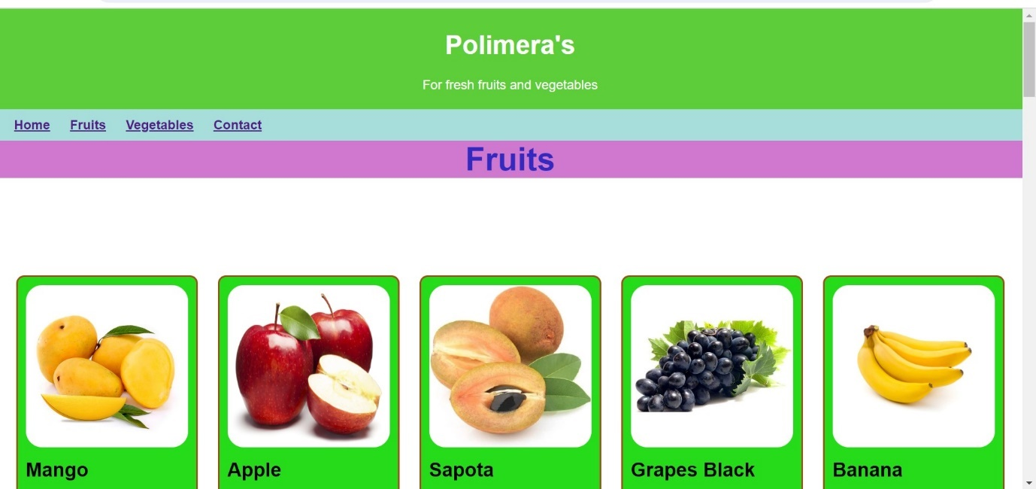

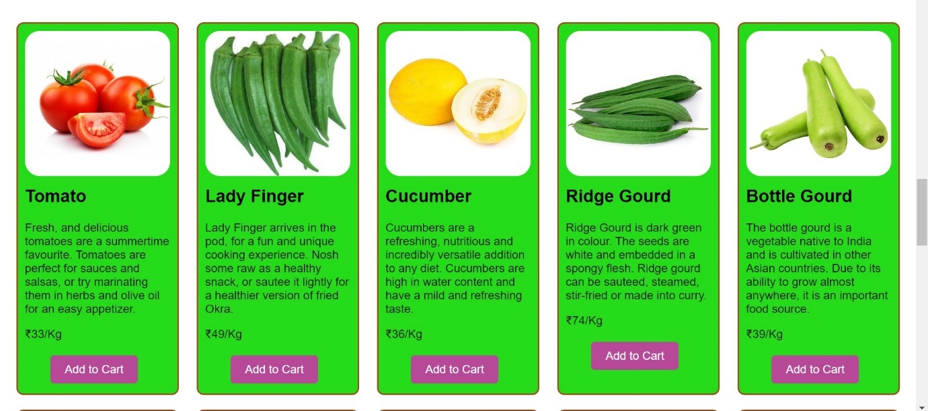

Use Case 12: Event Registration Landing Page

Description:

Create a landing page for an upcoming event, such as a conference or workshop. The page should provide information about the event, including date, location, agenda, and registration details. Design the page layout using HTML and CSS, and consider using CSS animations or transitions to enhance user engagement. Include a registration form for attendees to sign up for the event.

**Event.html:**

<!DOCTYPE html>

<html lang="en">

<head>

    <meta charset="UTF-8">

    <meta name="viewport" content="width=device-width, initial-scale=1.0">

    <title>Event Registration Landing Page</title>

    <link rel="stylesheet" href="Event.css">

</head>

<body>

    <header>

        <h1>TechFest 2k24</h1>

        <p>Where Innovation Meets Reality</p>

        <img src="Images/Logo.png" alt="logo">

      </header>

      <section class="about">

        <div>

            <h2>About The Event</h2>

            <p>TechFest is an annual gathering of visionaries, technologists, and industry leaders coming together to explore the latest trends, innovations, and disruptions shaping our digital future. Join us for two days of insightful talks, interactive workshops, and networking opportunities.</p>

        </div>

        <img class="abt-img" src="Images/fest.webp" alt="fest">

      </section>

      <section class="details">

        <div>

            <h2>Event Details</h2>

            <p><strong>Date:</strong> 11<sup>th</sup> and 12<sup>th</sup> May, 2024</p>

            <p><strong>Location:</strong> N Convention, Madhapur, Hyderabad.</p>

            <p><strong>Theme:</strong> "Unlocking the Potential of Emerging Technologies"</p>

        </div>

        <img class="det-img" src="Images/N-convention.jpg" alt="place">

      </section>

      <section class="guest">

        <h2>Chief Guests</h2>

        <div>

          <h3>N.R.Narayana Murthy</h3>

          <p class="abt-gst">Founder of Infosys</p>

          <p>Nagavara Ramarao Narayana Murthy is an Indian billionaire businessman. He is one of the seven co-founders of Infosys, and has previously served as the chairman, chief executive officer, president, and chief mentor of the company before retiring and taking the title chairman emeritus.</p>

            <img class="guest-img" src="Images/Narayana murthy.jpg" alt="NRM">

        </div>

        <div>

          <h3>Ratan Naval Tata</h3>

          <p class="abt-gst">Former chairman of Tata Group</p>

          <p>Ratan Naval Tata is an Indian industrialist, philanthropist and former chairman of Tata Sons. He was a chairman of the Tata Group from 1990 to 2012, and interim chairman from October 2016 through February 2017. He continues to head its charitable trusts.</p>

            <img class="guest-img" src="Images/Ratan tata.jpg" alt="RT">

        </div>

      </section>

      <section class="schedule">

        <h2>Schedule Highlights</h2>

            <div class="day">

                <h3 style="text-align: center;"><strong>Day 1</strong></h3>

                    <ul>

                        <li>9:00 AM - Registration</li>

                        <li>10:00 AM - Opening Keynote: N.R.Narayana Murthy</li>

                        <li>11:30 AM - Panel Discussion: "Future of AI and Software Technology"</li>

                        <li>1:00 PM - Lunch Break</li>

                        <li>2:30 PM - Workshop: "Introduction to AI"</li>

                        <li>4:00 PM - Music Performance"</li>

                    </ul>

                </div>

                <img class="img-p1" src="Images/Music.jpg" alt="Music">

                <img class="img-t1" src="Images/AI.webp" alt="tech1">

            <div class="day">

                <h3 style="text-align: center;"><strong>Day 2</strong></h3>

                    <ul>

                        <li>9:30 AM - Morning Coffee</li>

                        <li>10:00 AM - Keynote: Ratan Naval Tata</li>

                        <li>11:30 AM - Panel Discussion: "Future of Transportation"</li>

                        <li>1:00 PM - Lunch Break</li>

                        <li>2:30 PM - Workshop: "Transformation of Electric Vehicles"</li>

                        <li>5:30 PM - Dance Performance</li>

                    </ul>

                </div>

                <img class="img-p2" src="Images/dance.jpg" alt="Dance">

                <img class="img-t2" src="Images/EV.jpg" alt="tech2">

    </section>

      <section class="registration">

          <div class="regbox">

            <h2>Registration</h2>

            <p>Don't miss this event! Reserve your spot now.</p>

            <form>

                <label for="name">Name:</label>

                <input type="text" id="name" name="name" placeholder="enter name" required><br><br>

                <label for="email">Email:</label>

                <input type="email" id="email" name="email" placeholder="enter email" required><br><br>

                <label for="gender">Gender:</label><br>

                <input type="radio" name="gender" id="male" value="male">

                <label for="male">Male</label><br>

                <input type="radio" name="gender" id="female" value="female">

                <label for="male">Female</label><br><br><br>

                <button type="submit">Register</button>

                <button type="submit" value="cancel">Cancel</button>

            </form>

        </div>

      </section>

      <footer>

        <p>&copy; 2024 TeckFest, All rights reserved.</p>

      </footer>

</body>

</html>

**Event.css:**

body {

    font-family: Arial, sans-serif;

    margin: 0;

    padding: 0;

  }

  header {

    color: #32b83b;

    text-align: center;

    padding: 20px 0;

    animation-name: color1;

    animation-duration:5s;

    animation-iteration-count: infinite;

  }

  @keyframes color1{

    0%{

      background-color: #171cb3a0;

    }

    100%{

      background-color: aqua;

    }

  }

  header img{

    border: 1px;

    border-radius: 50%;

    width: 200px;

    height: 120px;

    margin-top: -120px;

    margin-right: 50px;

    float: left;

    margin-left: 90px;

  }

  .about{

    background-color: rgba(36, 202, 202, 0.813);

    border: 1px solid;

  }

  .about div{

      width: 500px;

      text-align: justify;

      padding-left: 100px;

      height: 180px;

    }

    .abt-img{

        border: 1px;

        border-radius: 10px;

        width: 300px;

        height: 170px;

        float: right;

        margin-top: -195px;

        padding-right: 50px;

    }

    .details{

      margin-top:-20px;

      animation-name: color2;

      animation-duration:3s;

      animation-iteration-count: infinite;

    }

  @keyframes color2{

    0%{

      background-color: rgb(160, 107, 38);

    }

    100%{

      background-color: rgb(32, 158, 36);

    }

  }

.details div{

    width: 500px;

    height: 190px;

    padding-left: 100px;

}

.det-img{

        border: 1px;

        border-radius: 20px;

        width: 400px;

        height: 200px;

        float: right;

        margin-top: -210px;

      }

  .guest{

    background-color: rgba(100, 30, 165, 0.571);

  }

  .guest div{

    background-color: darksalmon;

    border: 2px solid;

    border-radius: 30px;

    width: 400px;

    height: 500px;

    padding:0 20px;

    display:inline-table;

    margin-left: 100px;

    text-align: justify;

  }

  .abt-gst{

    font-weight: bold;

  }

  .guest-img{

    border: 1px;

    border-radius: 60px;

    width: 200px;

    height: 200px;

    margin-left: 90px;

    margin-top: 20px;

  }

  .schedule{

    animation-name: color1;

    animation-duration:3s;

    animation-iteration-count: infinite;

  }

  @keyframes color1{

    0%{

      background-color: rgba(216, 136, 37, 0.696);

    }

    50%{

      background-color: #8aad31a0;

    }

    100%{

      background-color: rgb(179, 94, 37);

    }

  }

  .day{

    width: 500px;

    margin-left: 400px;

    padding: 20px 0;

  }

  .img-p1{

    border: 1px;

    border-radius: 50px;

    width: 300px;

    height: 200px;

    margin-top: -200px;

    margin-right: 50px;

    float: right;

  }

  .img-t1{

    border: 1px;

    border-radius: 50px;

    width: 300px;

    height: 200px;

    margin-top: -200px;

    margin-right: 50px;

    float: left;

    margin-left: 50px;

  }

  .img-p2{

    border: 1px;

    border-radius: 50px;

    width: 300px;

    height: 200px;

    margin-top: -200px;

    margin-right: 50px;

    float: right;

  }

  .img-t2{

    border: 1px;

    border-radius: 50px;

    width: 300px;

    height: 200px;

    margin-top: -200px;

    margin-right: 50px;

    float: left;

    margin-left: 50px;

  }

  .registration{

    background-color: rgba(229, 106, 19, 0.813);

  }

  .regbox{

    background-color: bisque;

    border: 1px solid;

    border-radius: 30px;

    width: 400px;

    height: 350px;

    padding:10px;

    padding-left: 50px;

    margin-left: 380px;

    margin-bottom: 30px;

    margin-top: 30px;

  }

  form{

    padding-left: 70px;

  }

      button{

        background-color:deepskyblue;

          border: 1px solid;

          border-radius: 15px;

          margin-left: 5px;

          width: 100px;

          height: 30px;

        }

        button:hover{

            background-color: rgba(210, 38, 195, 0.84);

            cursor: pointer;

}

  section {

    padding: 20px;

  }

  h2{

    text-align: center;

  }

  footer p{

    margin: 0;

    padding: 25px;

    height: 30px;

    text-align: center;

    background-color: darkgray;

  }

  Output:

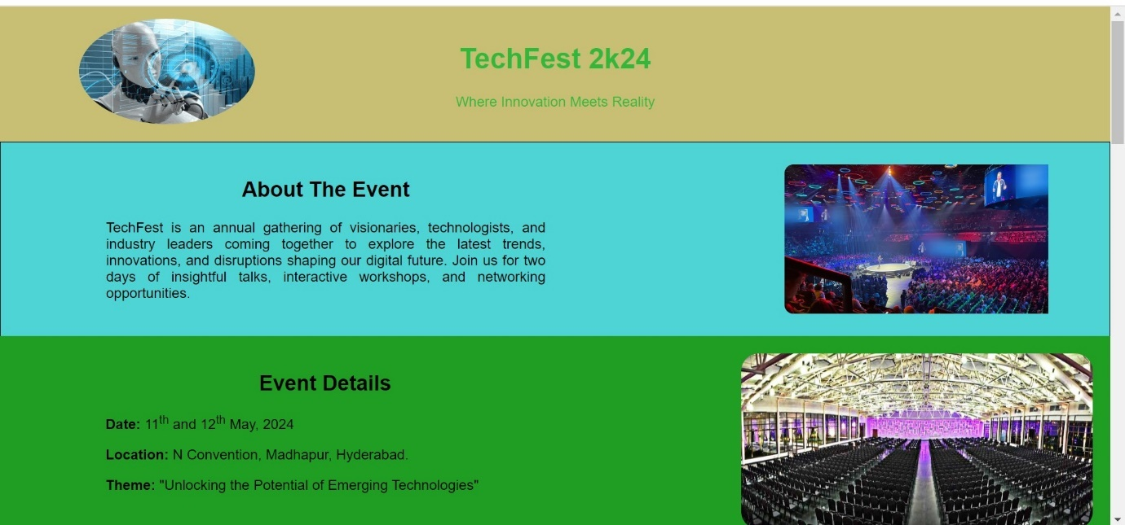

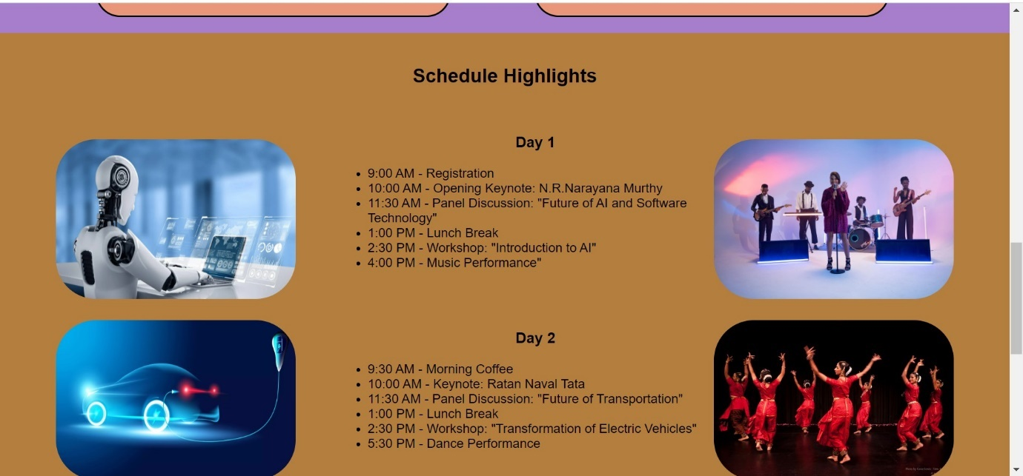

Use Case 13: Portfolio Website

Description:

Design and develop a personal portfolio website to showcase your projects, skills, and experience. The website should include sections for an about me, portfolio projects with descriptions and images, skills, and contact information. Use HTML to structure the content and CSS to style the layout and appearance of the website. Ensure the website is responsive and accessible on different devices.

**Portfolio.html:**

<!doctype html>

<html>

    <head>

        <meta charset="utf-8">

        <meta http-equiv="X-UA-Compatible" content="IE=edge">

        <meta name="viewport" content="width=device-width, initial-scale=1">

        <link href="https://fonts.googleapis.com/css?family=Poppins:100,200,300,400,500,600,700,800,900&amp;subset=devanagari,latin-ext" rel="stylesheet">

        <link rel="stylesheet" href="https://cdnjs.cloudflare.com/ajax/libs/font-awesome/4.7.0/css/font-awesome.min.css">

        <title>Nithish</title>

        <link rel="shortcut icon" type="image/icon" href="assets/logo/Photo.jpg"/>

        <link rel="stylesheet" href="assets/css/bootstrap.min.css">

        <link rel="stylesheet" href="assets/css/Portfolio.css">

    </head>

    <body>

        <header class="top-area">

            <div class="header-area">

                <nav class="navbar navbar-default bootsnav navbar-fixed dark no-background">

                    <div class="container">

                        <div class="navbar-header">

                            <button type="button" class="navbar-toggle" data-toggle="collapse" data-target="#navbar-menu">

                                <i class="fa fa-bars"></i>

                            </button>

                            <a class="navbar-brand" href="index.html">Nithish</a>

                        </div>

                        <div class="collapse navbar-collapse menu-ui-design" id="navbar-menu">

                            <ul class="nav navbar-nav navbar-right" data-in="fadeInDown" data-out="fadeOutUp">

                            <li class=" smooth-menu active"></li>

                                <li class="smooth-menu"><a href="#about me">about me</a></li>

                                <li class="smooth-menu"><a href="#projects">projects</a></li>

                                <li class="smooth-menu"><a href="#skills">skills</a></li>

                                <li class="smooth-menu"><a href="#contact">contact</a></li>

                            </ul>

                        </div>

                    </div>

                </nav>

            </div>

            <div class="clearfix"></div>

        </header>

        <section id="welcome-hero" class="welcome-hero">

            <div class="container">

                <div class="row">

                    <div class="col-md-12 text-center">

                        <div class="header-text">

                            <h2>Hi! <br> I am <br> Nithish Kumar <span>.</span>   </h2>

                            <p>JavaScript Developer</p>

                        </div>

                    </div>

                </div>

            </div>

        </section>

        <section id="about me" class="about me">

            <div class="section-heading text-center">

                <h2>about me</h2>

            </div>

            <div class="container">

                <div class="about-content">

                    <div class="row">

                        <div class="col-sm-6">

                            <div class="single-about-txt">

                                <h3>

                                    I am a Professional JavaScript Developer. I can design and develop beautiful websites with my own talent. I am able to use different kind of frame works and libraries to get wonderful srtucture for applications.

                                </h3>

                                <p>

                                    I had worked on different projects in my past. I have worked for different clients and companies. Currently I am working for Greemus.

                                </p>

                                <div class="row">

                                    <div class="col-sm-4">

                                        <div class="single-about-add-info">

                                            <h3>phone</h3>

                                            <p>9390785895</p>

                                        </div>

                                    </div>

                                    <div class="col-sm-4">

                                        <div class="single-about-add-info">

                                            <h3>email</h3>

                                            <p>potlapula.nithish@gmail.com</p>

                                        </div>

                                    </div>

                                </div>

                            </div>

                        </div>

                        <div class="col-sm-offset-1 col-sm-5">

                            <div class="single-about-img">

                                <img src="assets/images/about/me.jpg" alt="profile_image">

                                <div class="about-list-icon">

                                    <ul>

                                        <li>

                                            <a href="https://www.linkedin.com/in/nithish-kumar-68281729a">

                                                <i  class="fa fa-linkedin" aria-hidden="true"></i>

                                            </a>

                                        </li>

                                        <li>

                                            <a href="https://www.instagram.com/nithish4234?igsh=MTFhMTFjOThtcDlvcw==">

                                                <i  class="fa fa-instagram" aria-hidden="true"></i>

                                            </a>

                                        </li>

                                    </ul>

                                </div>

                            </div>

                        </div>

                    </div>

                </div>

            </div>

        </section>

        <section id="projects" class="projects">

            <div class="section-heading text-center">

                <h2>projects</h2>

            </div>

            <div class="container">

                <div class="education-horizontal-timeline">

                    <div class="row">

                        <div class="col-sm-4">

                            <div class="single-horizontal-timeline">

                                <div class="experience-time">

                                    <h1>Project 1</h1>

                                    <h3>Smart Parking System</h3><br>

                                    <h2>2022</h2>

                                </div>

                                <div class="timeline-horizontal-border">

                                    <i class="fa fa-circle" aria-hidden="true"></i>

                                    <span class="single-timeline-horizontal"></span>

                                </div>

                                <div class="timeline">

                                    <div class="timeline-content">

                                        <h4 class="title">

                                            Mini Project Using Java

                                        </h4><br>

                                        <p class="description">

                                            Smart parking system is a small project for parking vehicles using technology. By using this, we can easily park vehicles in parking areas and can find the vehicle location with our mobiles. It reduces time.</p>

                                    </div>

                                </div>

                            </div>

                        </div>

                        <div class="col-sm-4">

                            <div class="single-horizontal-timeline">

                                <div class="experience-time">

                                    <h1>Project 2</h1>

                                    <h3>Chatbot Using Python</h3><br>

                                    <h2>2023</h2>

                                </div>

                                <div class="timeline-horizontal-border">

                                    <i class="fa fa-circle" aria-hidden="true"></i>

                                    <span class="single-timeline-horizontal"></span>

                                </div>

                                <div class="timeline">

                                    <div class="timeline-content">

                                        <h4 class="title">

                                            Mini project using Python

                                        </h4><br>

                                        <p class="description">

                                            It is a simple and responsive Chatbot project using python. It responds to the user questions and gives replies based on the database. We can use it in wesites to solve small queries or simple questions of users.

                                        </p>

                                    </div>

                                </div>

                            </div>

                        </div>

                        <div class="col-sm-4">

                            <div class="single-horizontal-timeline">

                                <div class="experience-time">

                                    <h1>Project 3</h1>

                                    <h3>Automatic Turn Off and On for Street Lights</h3><br>

                                    <h2>2024</h2>

                                </div>

                                <div class="timeline-horizontal-border">

                                    <i class="fa fa-circle" aria-hidden="true"></i>

                                    <span class="single-timeline-horizontal spacial-horizontal-line

                                    "></span>

                                </div>

                                <div class="timeline">

                                    <div class="timeline-content">

                                        <h4 class="title">

                                            Mini project using DotNet

                                        </h4><br>

                                        <p class="description">

                                            It is an automatic turn off and turn on system for street lights. By using dotNet technology, we can set the times. So that it can control the lights that when they should turn on and turn off based on the given timings. It can saves time and energy.</p>

                                    </div>

                                </div>

                            </div>

                        </div>

                    </div>

                </div>

            </div>

        </section>

        <section id="skills" class="skills">

                <div class="skill-content">

                    <div class="section-heading text-center">

                        <h2>skills</h2>

                    </div>

                    <div class="container">

                        <div class="row">

                            <div class="col-md-6">

                                <div class="single-skill-content">

                                    <div class="barWrapper">

                                        <span class="progressText">Java</span>

                                        <div class="single-progress-txt">

                                            <div class="progress ">

                                                <div class="progress-bar" role="progressbar" aria-valuenow="70" aria-valuemin="30" aria-valuemax="100" style="">

                                                </div>

                                            </div>

                                            <h3>70%</h3>

                                        </div>

                                    </div>

                                    <div class="barWrapper">

                                        <span class="progressText">sql</span>

                                        <div class="single-progress-txt">

                                            <div class="progress ">

                                               <div class="progress-bar" role="progressbar" aria-valuenow="55" aria-valuemin="45" aria-valuemax="100" style="">

                                               </div>

                                            </div>

                                            <h3>55%</h3>

                                        </div>

                                    </div>

                                    <div class="barWrapper">

                                        <span class="progressText">php</span>

                                        <div class="single-progress-txt">

                                            <div class="progress ">

                                               <div class="progress-bar" role="progressbar" aria-valuenow="67" aria-valuemin="33" aria-valuemax="100" style="">

                                               </div>

                                            </div>

                                            <h3>67%</h3>

                                        </div>

                                    </div>

                                    <div class="barWrapper">

                                        <span class="progressText">HTML</span>

                                        <div class="single-progress-txt">

                                            <div class="progress ">

                                               <div class="progress-bar" role="progressbar" aria-valuenow="40" aria-valuemin="60" aria-valuemax="100" style="">

                                               </div>

                                            </div>

                                            <h3>40%</h3>

                                        </div>

                                    </div>

                                </div>

                            </div>

                            <div class="col-md-6">

                                <div class="single-skill-content">

                                    <div class="barWrapper">

                                        <span class="progressText">css</span>

                                        <div class="single-progress-txt">

                                            <div class="progress ">

                                                <div class="progress-bar" role="progressbar" aria-valuenow="40" aria-valuemin="60" aria-valuemax="100" style="">

                                                </div>

                                            </div>

                                            <h3>40%</h3>

                                        </div>

                                    </div>

                                    <div class="barWrapper">

                                        <span class="progressText">Java Script</span>

                                        <div class="single-progress-txt">

                                            <div class="progress ">

                                               <div class="progress-bar" role="progressbar" aria-valuenow="30" aria-valuemin="70" aria-valuemax="100" style="">

                                               </div>

                                            </div>

                                            <h3>30%</h3>

                                        </div>

                                    </div>

                                    <div class="barWrapper">

                                        <span class="progressText">communication</span>

                                        <div class="single-progress-txt">

                                            <div class="progress ">

                                               <div class="progress-bar" role="progressbar" aria-valuenow="55" aria-valuemin="45" aria-valuemax="100" style="">

                                               </div>

                                            </div>

                                            <h3>55%</h3>

                                        </div>

                                    </div>

                                    <div class="barWrapper">

                                        <span class="progressText"> creativity</span>

                                        <div class="single-progress-txt">

                                            <div class="progress ">

                                               <div class="progress-bar" role="progressbar" aria-valuenow="70" aria-valuemin="30" aria-valuemax="100" style="">

                                               </div>

                                            </div>

                                            <h3>70%</h3>

                                        </div>

                                    </div>

                                </div>

                            </div>

                        </div>

                    </div>

                </div>

        </section>

        <section id="contact" class="contact">

            <div class="section-heading text-center">

                <h2>contact me</h2>

            </div>

            <div class="container">

                <div class="contact-content">

                    <div class="row">

                        <div class="col-md-offset-1 col-md-5 col-sm-6">

                            <div class="single-contact-box">

                                <div class="contact-form">

                                    <form>

                                        <div class="row">

                                            <div class="col-sm-6 col-xs-12">

                                                <div class="form-group">

                                                  <input type="text" class="form-control" id="name" placeholder="Name*" name="name">

                                                </div>

                                            </div>

                                            <div class="col-sm-6 col-xs-12">

                                                <div class="form-group">

                                                    <input type="email" class="form-control" id="email" placeholder="Email*" name="email">

                                                </div>

                                            </div>

                                        </div>

                                        <div class="row">

                                            <div class="col-sm-12">

                                                <div class="form-group">

                                                    <input type="text" class="form-control" id="subject" placeholder="Subject" name="subject">

                                                </div>

                                            </div>

                                        </div>

                                        <div class="row">

                                            <div class="col-sm-12">

                                                <div class="form-group">

                                                    <textarea class="form-control" rows="8" id="comment" placeholder="Message" ></textarea>

                                                </div>

                                            </div>

                                        </div>

                                        <div class="row">

                                            <div class="col-sm-12">

                                                <div class="single-contact-btn">

                                                  <a class="contact-btn" href="#" role="button">submit</a>

                                                </div>

                                            </div>

                                        </div>

                                    </form>

                                </div><!--/.

                            </div>

                        </div>

                        <div class="col-md-offset-1 col-md-5 col-sm-6">

                            <div class="single-contact-box">

                                <div class="contact-adress">

                                    <div class="contact-add-head">

                                        <h3>Nithish Kumar</h3>

                                        <p>JavaScript Developer</p>

                                    </div>

                                    <div class="contact-add-info">

                                        <div class="single-contact-add-info">

                                            <h3>phone</h3>

                                            <p>9390785895</p>

                                        </div>

                                        <div class="single-contact-add-info">

                                            <h3>email</h3>

                                            <p>potlapula.nithish@gmail.com</p>

                                        </div>

                                        </div>

                                    </div>

                                </div>

                                <div class="hm-foot-icon">

                                    <ul>

                                        <li><a href="https://www.linkedin.com/in/nithish-kumar-68281729a"><i class="fa fa-linkedin"></i></a></li>

                                        <li><a href="https://www.instagram.com/nithish4234?igsh=MTFhMTFjOThtcDlvcw=="><i class="fa fa-instagram"></i></a></li>

                                    </ul>

                                </div>

                            </div>

                        </div>

                    </div>

                </div>

            </div>

        </section>

        <footer id="footer-copyright" class="footer-copyright">

            <div class="container">

                <div class="hm-footer-copyright text-center">

                    <p>

                        &copy; copyrights reserved. design and developed by <a href="https://www.themesine.com/">nithish</a>

                    </p>

                </div>

            </div>

        </footer>

    </body>

</html>

**Portfolio.css:**

*{

    padding: 0;

    margin: 0;

}

*{

    -webkit-box-sizing:border-box;

    -moz-box-sizing:border-box;

    -o-box-sizing:border-box;

    -ms-box-sizing:border-box;

    box-sizing:border-box;

}

body{

    font-family: 'Poppins', sans-serif;

    font-size:16px;

    color: #676a81;

    background: #fff;

    max-width:1920px;

    margin:0 auto;

    overflow-x:hidden;

}

a,a:hover,a:active,a:focus {

    display:inline-block;

    text-decoration:none;

    color: #6a708e;

    font-size:16px;

    padding:0;

}

h1,h2,h3,h4,h5,h6 {

    margin: 0;

    color:#43485c;

    font-size: 16px;

    font-family: 'Poppins', sans-serif;

    text-transform: capitalize;

}

p {

    margin: 0;

    line-height:1.8;

    color:#43485c;

    font-size:14px;

    font-family: 'Poppins', sans-serif;

}

img{border:none;max-width:100%; height:auto;}

ul{

    padding: 0;

    margin: 0 auto;

    list-style: none;

}

ul li {

    list-style: none;

}

select,input,textarea,button{box-shadow:none;outline:0!important;}

button {background: transparent;border: 0;}

html,body{

    height: 100%;

    position: relative;

}

[placeholder]:focus::-webkit-input-placeholder {

  -webkit-transition: opacity 0.3s 0.3s ease;

  -moz-transition: opacity 0.3s 0.3s ease;

  -ms-transition: opacity 0.3s 0.3s ease;

  -o-transition: opacity 0.3s 0.3s ease;

  transition: opacity 0.3s 0.3s ease;

  opacity: 0;

}

.fix{position: relative;clear: both;}

.top-area {

    position: relative;

    z-index: 9999;

}

@media (min-width: 1024px){}

nav.navbar.bootsnav.no-background {

    background-color: #fff;

    border: none;

}

nav.navbar.bootsnav {

    background-color: #fff;

    border-bottom: transparent;

    box-shadow: 0 3px 15px rgba(0,0,0,.2);

}

.navbar-header a.navbar-brand,.navbar-header a.navbar-brand:hover,.navbar-header a.navbar-brand:focus {

    display: inline-block;

    color: #d92cf9;

    font-size: 20px;

    font-weight: 600;

    padding: 33px 0px 57px;

    text-transform: uppercase;

}

nav.navbar.bootsnav ul.nav > li > a {

    font-size: 16px;

    font-weight: 400;

    text-transform:uppercase;

    -webkit-transition: 0.3s linear;

    -moz-transition: 0.3s linear;

    -ms-transition: 0.3s linear;

    -o-transition: 0.3s linear;

    transition: 0.3s linear;

}

nav.navbar.bootsnav ul.nav > li > a {padding: 35px 20px;}

nav.navbar.bootsnav ul.nav > li > a:hover,nav.navbar.bootsnav ul.nav > li > a:focus,nav.navbar.bootsnav ul.nav > li.active>a{color: #d92cf9;}

nav.navbar.bootsnav ul.nav > li.dropdown > a.dropdown-toggle:after {

    content: "";

}

nav.navbar.bootsnav ul.nav > li.dropdown span {

    font-size: 8px;

    margin-left: 15px;

}

.sticky-wrapper.is-sticky nav.navbar.bootsnav ul.nav > li > a {color:#6a708e;}

.sticky-wrapper.is-sticky nav.navbar.bootsnav ul.nav > li > a:hover,.sticky-wrapper.is-sticky nav.navbar.bootsnav ul.nav > li > a:focus,.sticky-wrapper.is-sticky nav.navbar.bootsnav ul.nav > li.active>a{color: #d92cf9;}

.menu-ui-design{overflow-y:scroll;height: 350px;}

.menu-ui-design::-webkit-scrollbar {

    width:5px;

}

.menu-ui-design::-webkit-scrollbar-track {

    -webkit-box-shadow: inset 0 0 8px #000;

}

.menu-ui-design::-webkit-scrollbar-thumb {

  background-color: #d92cf9;

}

nav.navbar.bootsnav .navbar-toggle {

    position: relative;

    background-color: transparent;

    border: 1px solid #d92cf9;

    padding: 10px;

    top: 0;

}

nav.navbar.bootsnav .navbar-toggle i{color: #d92cf9;}

.welcome-hero{

    display: flex;

    align-items: center;

    justify-content: center;

    position:relative;

    background:url(../images/about/welcome-banner.jpg)no-repeat;

    background-size:cover;

    background-position: center;

    height:890px;

}

.welcome-hero:before{

    position:absolute;

    content: " ";

    top:0;

    left:0;

    background:rgba(31,44,108,.65);

    width:100%;

    height:100%;

}

.header-text h2 {

    color: #fff;

    font-size: 54px;

    font-weight: 700;

    text-transform: uppercase;

    line-height: 1.5;

}

.header-text h2 span {color: #d92cf9;}

.header-text p {

    color: #fff;

    font-size: 20px;

    font-weight: 300;

    text-transform: uppercase;

    margin: 30px 0 60px;

    letter-spacing: 1px;

}

.header-text a {

    width: 200px;

    height: 60px;

    line-height: 60px;

    border-radius: 3px;

    text-transform: capitalize;

    color: #fff;

    background: #b636ff;

    border:1px solid #b636ff;

    box-shadow: 0 5px 20px rgba(0,0,0,.2);

    -webkit-transition: 0.3s linear;

    -moz-transition: 0.3s linear;

    -ms-transition: 0.3s linear;

    -o-transition: 0.3s linear;

    transition: 0.3s linear;

}

.header-text a:hover{ box-shadow: 0 5px 20px rgba(0,0,0,.4);background:#9f00ff;border: 1px solid #9f00ff;}

.about {padding: 50px 0 100px;}

.about-content {padding-top: 100px;}

.single-about-txt h3 {

    font-size:18px;

    color: #3c4258;

    text-transform: initial;

    line-height: 1.8;

}

.single-about-txt p {

    font-size: 16px;

    color: #999fb3;

    padding: 35px 0 43px;

    border-bottom: 1px solid #999fb3;

}

.single-about-add-info {

    margin: 35px 0;

}

 .single-about-add-info h3 {

    color: #636a82;

    font-size: 16px;

    text-transform: capitalize;

}

.single-about-add-info p {font-weight:  300;border:  0;padding: 0;margin-top: 3px;}

.single-about-img img {

    max-width: 300px;

    height: 400px;

}

.about-list-icon{

    display: flex;

    justify-content: center;

    align-items: center;

    position: absolute;

    width: 212px;

    height: 50px;

    background: #1f2c6c;

}

.about-list-icon ul {

    display: flex;

}

.about-list-icon  ul li a {

    padding-right: 22px;

    cursor:pointer;

    color: #fff;

}

.about-list-icon ul li a {

    cursor: pointer;

    color: #fff;

    display: inline-block;

    border: 2px solid;

    margin-left: 20px;

    border-radius: 8px;

    width: 30px;

    height: 30px;

    line-height: 28px;

    text-align: center;

}

.about-list-icon ul li a i {

    margin-left: 6px;

}

.education {

    background:  #f9fbfd;

    padding-top:  50px;

}

.education-horizontal-timeline {

    padding: 80px 0;

}

.education-horizontal-timeline .col-sm-4 {padding:0 2px;}

.single-horizontal-timeline .experience-time h3{text-transform: capitalize;}

.single-horizontal-timeline .experience-time h3 span{text-transform:lowercase;}

.single-horizontal-timeline .timeline-content h5 {margin: 15px 0;}

.single-horizontal-timeline p {color: #999fb3;max-width: 335px;}

.timeline-horizontal-border {

    display:  flex;

    align-items: center;

    padding: 26px 0 30px;

}

.timeline-horizontal-border i {

    font-size:  10px;

    color: #d92cf9;

    margin-right:  5px;

}

span.single-timeline-horizontal {

    display:  inline-block;

    background: #b2c1ce;

    height:  1px;

    width: 380px;

}

span.single-timeline-horizontal.spacial-horizontal-line {width: 88px;}

.skill-content{padding: 50px 0 80px;}

.single-skill-content{padding-top: 100px;}

.section-heading h2 {

    font-size: 24px;

    font-weight: 600;

    text-transform: uppercase;

    padding-bottom: 50px;

    border-bottom: 1px solid #e5ebf2;

}

.single-progress-txt {

    display: flex;

}

.single-progress-txt h3 {

    width: 10%;

    color: #a606c3;

    position: relative;

    top: 6px;

    left: 20px;

}

.barWrapper {

    font-weight: 400;

    font-size: 16px;

    text-transform: uppercase;

}

.progress {

    border-radius:3px;

    overflow: visible;

    background: #e6ecf3;

    height:8px;

    margin-top: 15px;

    width: 85%;

    margin-bottom: 37px;

}

.progress-bar {

   background: #b636ff;

    border-radius: 3px;

   -webkit-transition: width 1.5s ease-in-out;

   -ms-transition: width 1.5s ease-in-out;

   -moz-transition: width 1.5s ease-in-out;

   -o-transition: width 1.5s ease-in-out;

   transition: width 1.5s ease-in-out;

}

.tooltip{

   position:relative;

   float:right;

}

.tooltip > .tooltip-inner {

   background-color: transparent;

   padding: 1px 5px;

   color: #b636ff;

   font-weight: 500;

   font-size: 12px;

   border-radius: 0;

}

.popOver + .tooltip > .tooltip-arrow {

   border-left: 6px solid transparent;

   border-right: 6px solid transparent;

   border-top: 6px solid #fff;

   bottom: -1px;

   transform: translateX(-50%);

   margin-left: 0;

}

.contact {

    background: #f9fbfd;

    padding: 50px 0 100px;

}

.single-contact-box {padding-top: 100px;}

.contact-form  .form-group {

    margin-bottom: 20px;

}

.contact-form .form-control {

    padding: 25px;

    font-size: 14px;

    border: 1px solid #fff;

    border-radius: 0px;

    box-shadow: none;

    outline: 0!important;

    background: #fff;

    color: #636a82;

    resize: none;

}

.contact-form .single-contact-btn {

    display:flex;

    align-items:center;

    justify-content:center;

    height:50px;

    text-transform:capitalize;

    margin-top: 3px;

    background: #b636ff;

    border: 1px solid #b636ff;

    cursor:pointer;

    box-shadow: 0 5px 20px rgba(0,0,0,.2);

     -webkit-transition: .5s;

    -moz-transition:.5s;

    -ms-transition:.5s;

    -o-transition:.5s;

    transition: .5s;

}

.contact-form .single-contact-btn .contact-btn ,

.contact-form .single-contact-btn .contact-btn:focus {

    margin-top:0px;

    outline: 0 !important;

    border:0;

    color: #fff;

    border-radius: 0px;

    font-size:14px;

    -webkit-transition: .5s;

    -moz-transition:.5s;

    -ms-transition:.5s;

    -o-transition:.5s;

    transition: .5s;

}

.single-contact-btn:hover{

    background: #9f00ff;

    border: 1px solid #9f00ff;

    box-shadow: 0 5px 20px rgba(0,0,0,.2);

}

.contact-add-head h3 {

    font-size:  24px;

    color:  #3c4258;

}

.contact-add-head p {

    font-size:  16px;

    text-transform: capitalize;

    color:  #636a82;

    font-weight:  300;

    margin-top:  6px;

}

.contact-add-info { margin: 42px 0 52px;}

.single-contact-add-info h3 {

    color:  #636a82;

    font-weight:  500;

}

.single-contact-add-info p {

    color:  #999fb3;

    font-size:  16px;

    margin-top:  18px;

}

.single-contact-add-info {

    margin-bottom:  26px;

}

.hm-foot-icon ul li>a {

    color: #636a82;

    margin-right:18px;

    -webkit-transition: .3s;

    -moz-transition:.3s;

    -ms-transition:.3s;

    -o-transition:.3s;

    transition: .3s;

}

.hm-foot-icon ul li>a:hover{

    color: #b636ff;

}/*hm-foot-icon*/

.hm-footer-copyright p{

    color: #888ea5;

    text-transform: capitalize;

    padding: 38px 0;

}

.hm-footer-copyright p a {color: #888ea5;}

**Output:**



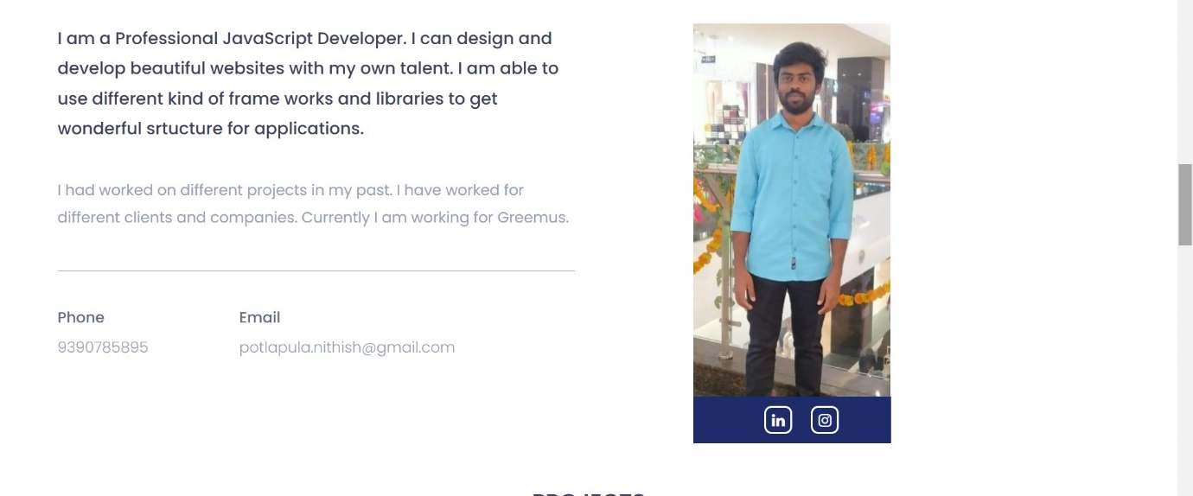

Use Case 14: Blog Website

Description:

Build a static blog website where users can read and interact with blog posts on various topics. Each blog post should include a title, author, publication date, content, and comments section. Design the layout of the blog website using HTML and CSS, and consider incorporating CSS grid or flexbox for the post listing and layout. Include navigation links to allow users to browse through different blog categories.

**Blog.html:**

<!DOCTYPE html>

<html lang="en">

<head>

    <meta charset="UTF-8">

    <meta name="viewport" content="width=device-width, initial-scale=1.0">

    <title>Blog</title>

    <link rel="stylesheet" href="Blog.css">

</head>

<body>

    <header>

        <div class="head">

            <h1>Nithish Blogs</h1>

            <p>

                One place for all blogs.

            </p>

            <img src="Images/blogs.jpg" alt="Blogs">

        </div>

            <nav>

                <a href="#All">All</a>

                <a href="#Sports">Sports</a>

                <a href="#Education">Education</a>

                <a href="#News">News</a>

            </nav>

    </header>

    <div class="about" id="All">

        <a href="#Sports"><img src="Images/sports.webp" alt="Sports"><p>Sports</p></a>

        <a href="#Education"><img src="Images/education.webp" alt="Education"><p>Education</p></a>

        <a href="#News"><img src="Images/news.jpg" alt="News"><p>News</p></a>

    </div>

    <div class="sports" id="Sports">

        <h2>Sports</h2>

        <div class="divs">

            <img src="Images/cricket.jpg" alt="Cricket">

            <h3>PIX: Gill, Sudharsan hit centuries as GT ease past CSK</h3>

            <p>publlished by <span class="author">HARISH KOTIAN</span> on May 10, 2024.</p>

            <p>Captain Shubman Gill cracked a blistering century while B Sai Sudharsan hit his maiden IPL ton as Gujarat Titans kept themselves in the play-offs race with a 35-run win over Chennai Super Kings in Ahmedabad on Friday.

                Sudharsan (103 off 51 balls) matched skipper Gill (104 off 55 deliveries) stroke for stroke as the two openers notched up destructive centuries to propel GT to 231/3.</p>

            <h5>Comments</h5>

        </div>

        <div class="divs">

                <img src="Images/chess.jpg" alt="Chess">

                <h3>How Gukesh Became A Chess Prodigy</h3>

                <p>publlished by <span class="author">A GANESH NADHAR</span> on April 22, 2024.</p>

            <p>Dommaraju Gukesh's historic win at the Candidates Chess Tournament in Toronto wasn't just a triumph for the young chess player, it was a testament to the unwavering support and sacrifices made by his parents.

                As Gukesh prepares for his historic world title challenge, the world can't help but acknowledge the silent heroes behind the prodigy: Dr Rajnikanth and Dr Padmakumari, who sacrificed their own routines and comfort to nurture a champion, discovers A Ganesh Nadar.</p>

            <h5>Comments</h5>

        </div>

    </div>

    <div class="education" id="Education">

        <h2>Education</h2>

        <div class="divs">

            <img src="Images/abroad.jpg" alt="Abroad">

            <h3>Studying abroad is more than just education, it's a holistic experience</h3>

            <p>publlished by <span>KARUN KANDOI</span> on May 09, 2024.</p>

            <p>Studying internationally offers a wider variety of courses, some also including research options and skill-based training for students. This helps expand your horizons and opens up a world of new educational opportunities. Not only this, certain programs abroad also allow you to take different courses at the same time. So you can pursue your interest in literature whilst studying mathematics as your major. </p>

            <h5>Comments</h5>

        </div>

        <div class="divs">

            <img src="Images/India.jpg" alt="India">

            <h3>Major Issues in the Indian Education System</h3>

            <p>publlished by <span>DHARMENDRA PRADHAN </span> on MAy 10, 2024.</p>

            <p>The Indian Education System has its share of issues and challenges which need to be resolved to provide better and improved education to children, who are the future of the country. Over the years, a lot has changed in the Indian education system but still, there are many loopholes and problems which need to be resolved. </p>

            <h5>Comments</h5>

        </div>

    </div>

    <div class="news" id="News">

        <h2>News</h2>

        <div class="divs">

            <img src="Images/world.jpg" alt="World">

            <h3>Israel-Gaza war: Biden to halt some arms supplies if Israel invades Rafah</h3>

            <p>publlished by <span>TUHIN DAS MAHAPATRA</span> on May 07, 2024.</p>

            <p>President Joe Biden has warned Israel that the US will stop supplying some weapons if it launches a major ground operation in the Gaza city of Rafah.

                "If they go into Rafah, I'm not supplying the weapons that have been used historically to deal with Rafah," he said during an interview with CNN.

                He added that he would "continue to make sure Israel is secure".</p>

                <h5>Comments</h5>

            </div>

            <div class="divs">

                <img src="Images/politics.webp" alt="Politics">

                <h3>Lok Sabha polls: PM Modi worried after 3rd phase, says Mallikarjun Kharge</h3>

                <p>publlished by <span>RAGHAV AGGARWAL</span> on May 08, 2024.</p>

                <p>Hitting out at the BJP and Prime Minister Narendra Modi, AICC president Mallikarjun Kharge on Friday said Modi and his cabinet colleague Amit Shah are "worried" after the third phase of the Lok Sabha elections and they started abusing the Congress party.

                    Addressing a press conference here, Kharge said to the BJP leaders, instead of seeking votes on their "development," they are abusing the Congress leaders and distorting their (Congress) leaders' speeches, which according to him, is not required.</p>

                <h5>Comments</h5>

            </div>

        </div>

    <footer>

        <p>&copy 2024 Nithish-blogs.com, All rights reserved</p>

    </footer>

</body>

</html>

**Blog.css:**

body{

    background-color: bisque;

}

.head{

    background-color: cornflowerblue;

    height: 130px;

    text-align: center;

    padding-top: 20px;

}

.head img{

    border-radius: 50px;

    width: 150px;

    height: 120px;

    float: left;

    margin-top: -120px;

    margin-left: 100px;

}

nav{

    background-color: chartreuse;

    padding: 10px;

}

nav a{

    background-color:coral;

    margin-left: 30px;

    padding: 5px 10px;

    font-weight: bold;

    border-radius: 5px;

}

.about{

    background-color: cornsilk;

    padding: 30px;

}

.about a{

    display: inline-block;

    padding-left: 80px;

}

.about a p{

    text-align: center;

    font-weight: bold;

    background-color:deeppink;

    padding: 5px 20px;

    border-radius: 15px;

}

.about a p:hover{

    background-color: darksalmon;

}

nav a:hover{

    background-color: dodgerblue;

}

.about img{

    width: 280px;

    height: 200px;

    border-radius: 50px;

}

h2{

    text-align: center;

    padding-top: 50px;

    background-color: cornflowerblue;

    padding: 10px;

}

img{

    width: 300px;

    height: 250px;

    border-radius: 20px;

}

.sports{

    background-color: deepskyblue;

}

.sports div{

    border: 1px solid;

    background-color:gainsboro;

    display:inline-flex;

    flex-direction: column;

    width: 300px;

    margin-left: 200px;

    padding: 20px;

}

.education{

    background-color: thistle;

}

.education div{

    border: 1px solid;

    background-color:gainsboro;

    display:inline-flex;

    flex-direction: column;

    width: 300px;

    margin-left: 200px;

    padding: 20px;

}

.news{

    background-color: lavender;

}

.news div{

    border: 1px solid;

    background-color:gainsboro;

    display:inline-flex;

    flex-direction: column;

    width: 300px;

    margin-left: 200px;

    padding: 20px;

}

.divs{

    border-radius: 30px;

    margin-top: 50px;

    height: auto;

    margin-bottom: 50px;

}

h5{

    background-color: floralwhite;

    padding: 5px 10px;

    width: 80px;

    cursor: pointer;

    border-radius: 7px;

}

h5:hover{

    background-color: rgba(127, 47, 47, 0.548);

}

footer{

    background-color: steelblue;

    text-align: center;

    height: 40px;

    padding-top: 8px;

}

**Output:**

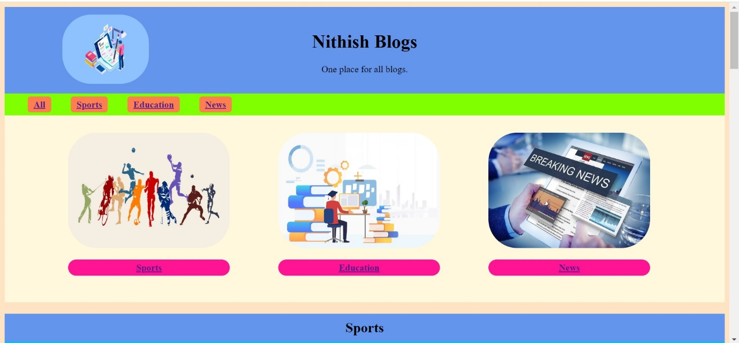

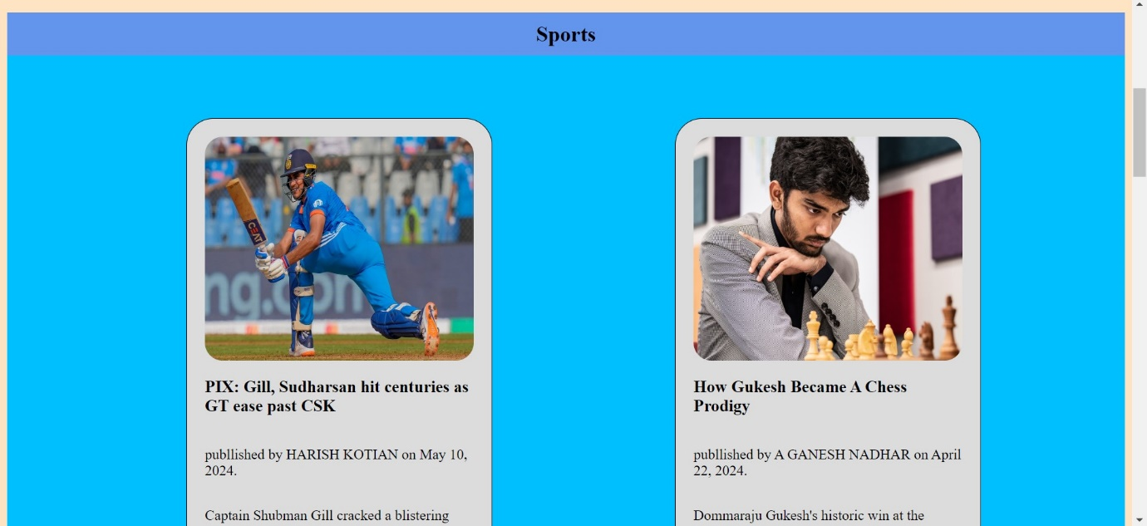

Use Case 15: Online Resume/CV

Description:

Create an online resume or curriculum vitae (CV) using HTML and CSS. The resume/CV should include sections for personal information, education, work experience, skills, projects, and contact details. Design the layout to present information clearly and professionally, using CSS styling to enhance readability and visual appeal. Ensure the resume/CV is responsive and accessible across different devices.

**Resume.html:**

<!DOCTYPE html>

<html lang="en">

<head>

  <meta charset="UTF-8">

  <meta name="viewport" content="width=device-width, initial-scale=1.0">

  <title>Resume</title>

  <link rel="stylesheet" href="https://cdnjs.cloudflare.com/ajax/libs/font-awesome/4.7.0/css/font-awesome.min.css">

  <link rel="stylesheet" href="Resume.css">

</head>

<body>

  <div class="container">

    <div class="profile">

      <div class="profile_container">

        <div class="profile_profileImg">

          <img src="images/Photo.jpg" alt="shaif arfan">

        </div>

        <div>

          <h1 class="profile_name">

            <span class="profile_name_firstName">Nithish Kumar</span>

          </h1>

          <p class="profile_title">Frontend Developer</p>

          <p class="description profile_description">

          </p>

          <a class="downloadBtn" href="Resume(NT).pdf" target="_blank" download="Resume.pdf">Download Resume</a>

        </div>

      </div>

    </div>

    <div class="group-1">

      <div class="skills">

        <h3 class="title">Skills</h3>

        <ul class="skills_list description">

          <li>HTML CSS</li>

          <li>JavaScript</li>

          <li>React JS</li>

          <li>Java</li>

          <li>sql</li>

        </ul>

      </div>

      <div class="edu">

        <h3 class="title">Education</h3>

        <div class="edu_item">

          <h4 class="item_title">B. Tech</h4>

          <p class="item_preTitle">2018-2022</p>

          <p class="item_subtitle">

            Malla Reddy Engineering College

          </p>

        </div>

        <div class="edu_item">

          <h4 class="item_title">Intermediate</h4>

          <p class="item_preTitle">2016-2018</p>

          <p class="item_subtitle">

            Vikas Junior College

          </p>

        </div>

        <div class="edu_item">

          <h4 class="item_title">SSC</h4>

          <p class="item_preTitle">2015-2016</p>

          <p class="item_subtitle">

            ZPSS Kallurugudem

          </p>

        </div>

      </div>

      <div class="certification">

        <h3 class="title">certifications</h3>

        <div class="certification_item">

          <p class="item_preTitle">2023</p>

          <h4 class="item_title">Oracle Certified Associate, Java SE 8 Programmer</h4>

          <p class="description">

            The associate level supplies users with the fundamentals of the platform, including the skills and knowledge vital for using basic Java languages and performing problem-solving solutions.

          </p>

        </div>

      </div>

    </div>

    <div class="group-2">

      <div class="exp">

        <h3 class="title">Experience</h3>

        <div class="exp_item">

          <p class="item_preTitle">2022-2024</p>

          <h4 class="item_title">Insol Applications Pvt. Ltd.</h4>

          <p class="item_subtitle">Java Developer</p>

          <p class=" description">

            Worked as a Java Developer with 2 years of experience. I have worked on eduation related projects and used Java, Spring, Sql and some basics of front end technologies.</p>

        </div>

      </div>

      <div class="group-2">

        <div class="exp">

          <h3 class="title">Projects</h3>

          <div class="exp_item">

            <h4 class="item_title">Skilled Resource Authentication Network(SRAN)</h4>

            <p class="item_preTitle">2022-2024</p>

            <p class="item_subtitle">Java Developer</p>

            <p class=" description">SRAN, Skilled Resource Authentication Network project helps Students, Educational institutions and various industry segments to work together. It also gives flexibility to the Government to supervise all the elements and streamline the process of tracking students through their various levels of Education and Employment.

              SRAN GLOBAL brings Education and Employment under one umbrella and the solution Integrates Companies with Educational Institutions for creating genuine employment.</p>

          </div>

        </div>

      </div>

      <div class="interest">

        <h3 class="title">Interests</h3>

        <div class="interest_items">

          <div class="interest_item">

            <i data-feather="music"></i>

            <span>Movies</span>

          </div>

          <div class="interest_item">

            <i data-feather="book"></i>

            <span>Music</span>

          </div>

          <div class="interest_item">

            <i data-feather="map"></i>

            <span>Travel</span>

          </div>

        </div>

      </div>

    </div>

  </div>

    <hr>

    <footer>

      <div class="box">

          <h3 class="title">Contact</h3>

          <div class="contact_info">

            <p class="description">

              Nithish Kumar

            </p>

            <p class="description">

              9390785895

            </p>

            <p class="description">

              potlapula.nithish@gmail.com

            </p>

          </div>

      </div>

      <div class="box">

        <div class="social">

          <h3 class="title">Socials</h3>

          <div class="social_items">

            <a href="https://www.linkedin.com/in/nithish-kumar-68281729a" target="_b" class="social_item">

              <i class="fa fa-linkedin-square"></i>

              <span>Linked in</span>

            </a>

            <a href="https://www.instagram.com/nithish4234?igsh=MTFhMTFjOThtcDlvcw==" target="_blank" class="social_item">

              <i class="fa fa-instagram"></i>

              <span>Instagram</span>

            </a>

          </div>

        </div>

      </div>

    </footer>

</body>

</html>

**Resume.css:**

* {

    padding: 0;

    margin: 0;

    box-sizing: border-box;

}

html {

    font-size: 10px;

}

body {

    font-family: Inter, sans-serif;

    background-color:cornsilk;

    color: white;

}

/* common styles */

img {

    width:200px;

    height: 250px;

}

a {

    text-decoration: none;

    color: white;

}

.description {

    margin-top: 1rem;

    font-size: 1.5rem;

    font-weight: 400;

    color: var(--text-color);

}

.title {

    color:blueviolet;

    font-weight: 700;

    font-size: 2rem;

    text-transform: uppercase;

}

.item_preTitle {

    font-size: 1.4rem;

    color: var(--text-color);

    font-weight: 300;

}

.item_title {

    font-size: 1.6rem;

    color: white;

    font-weight: 500;

    margin: 0.8rem 0;

}

.item_subtitle {

    font-size: 1.4rem;

    color: var(--text-color);

    font-weight: 400;

}

/* layouts */

.container {

    max-width: 1000px;

    width: 90%;

    margin: 0 auto;

    display: grid;

    padding: 5rem;

    background-color: darkgrey;

    grid-template-columns: 1fr 1fr;

    gap: 4rem;

    margin-top: 40px;

}

@media only screen and (max-width: 768px) {

    .container {

        width: 100%;

        grid-template-columns: 1fr;

        padding: 3rem;

        gap: 7rem;

    }

}

.profile {

    grid-column: 1 / -1;

    margin-bottom: 2rem;

}

.group-1,

.group-2 {

    display: flex;

    flex-direction: column;

    gap: 5rem;

}

.group-3 {

    max-width: 500px;

    width: 100%;

    gap: 50px;

    display: flex;

    flex-direction: row;

}

@media only screen and (max-width: 768px) {

    .profile {

        margin-bottom: 0;

    }

    .group-3 {

        flex-direction: column;

    }

}

/* profile */

.profile_container {

    display: flex;

    padding-left: 50px;

    gap: 50px;

}

.profile_profileImg {

    max-width: 250px;

}

.profile_name_firstName {

    color: rgb(52, 44, 160);

    font-weight: 200;

    font-size: clamp(2rem, 8vw, 4rem);

    text-transform: uppercase;

    display: block;

    margin-top: 50px;

}

.profile_title {

    font-size: 20px;

    font-weight: 400;

    text-transform: uppercase;

    color: brown;

    padding-top: 20px;

}

.downloadBtn {

    display: block;

    width: 150px;

    text-decoration: underline;

    font-size: 1.6rem;

    margin-top: 1rem;

}

.downloadBtn:hover {

    color: var(--primary-color);

}

@media only screen and (max-width: 768px) {

    .profile_container {

        flex-direction: column;

    }

}

/* Expertise */

.skills_list {

    margin-top: 1rem;

    margin-left: 2rem;

    line-height: 2;

}

/* eduction */

.edu_item {

    margin-top: 2rem;

}

/* certification */

.certification_item {

    margin-top: 2rem;

}

/* exp */

.exp_item {

    margin-top: 2rem;

}

/* Interests */

.interest{

    margin-top: 24px;

}

.interest_items {

    margin-top: 10px;

    display: flex;

    flex-direction: column;

    gap: 2rem;

}

.interest_item {

    font-size: 1.5rem;

    display: flex;

    flex-direction: column;

    justify-content: center;

    padding-left: 10px;

    gap: 0.5rem;

    color: var(--text-color);

}

.interest_item svg {

    width: 2rem;

}

/* socials */

.social{

    margin-left: -20px;

}

.social_item {

    font-size: 1.5rem;

    display: flex;

    gap: 1rem;

    align-items: center;

    justify-content: flex-start;

    color: var(--text-color);

    padding-top: 10px;

}

.social_item:hover {

    color: var(--primary-color);

}

.social_item svg {

    width: 2rem;

}

hr {

    width: 500px;

    margin: 0 auto;

}

footer{

    margin-left: 128px;

    display:flex;

    margin-left: 132px;

    margin-bottom: 50px;

    }

.box{

    background-color: darkgrey;

    width: 500px;

    padding-left: 50px;

    padding-top: 20px;

    padding-bottom: 20px;

}

Output:

